Snowflake External Functions with AWS Lambda 28/08/2025

This document is primarily based on this blog post:

https://interworks.com/blog/2020/08/14/zero-to-snowflake-setting-up-snowflake-external-functions-with-aws-lambda/

One possible (and indeed powerful) way of leveraging and integrating the Python language within snowflake is to use AWS Lambda functions where Python functions can be created in AWS and called from Snowflake with variables and parameters fed directly from Snowflake.

I have a free 12 month (trial) AWS account here (garth.jones@nhs.net) to log on:
https://us-east-1.console.aws.amazon.com/

Note that MFA (multi factor authentication) has been enabled to access this account using the Google Authenticator application on a mobile phone (scanning a QR code from AWS into the App).

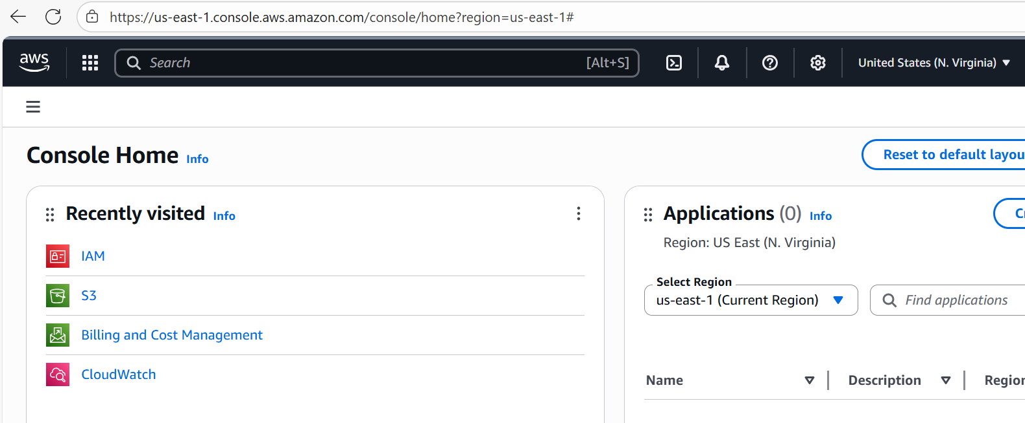

Having logged into an AWS cloud account, let us first consider the integration set up between snowflake and an AWS Lambda function:

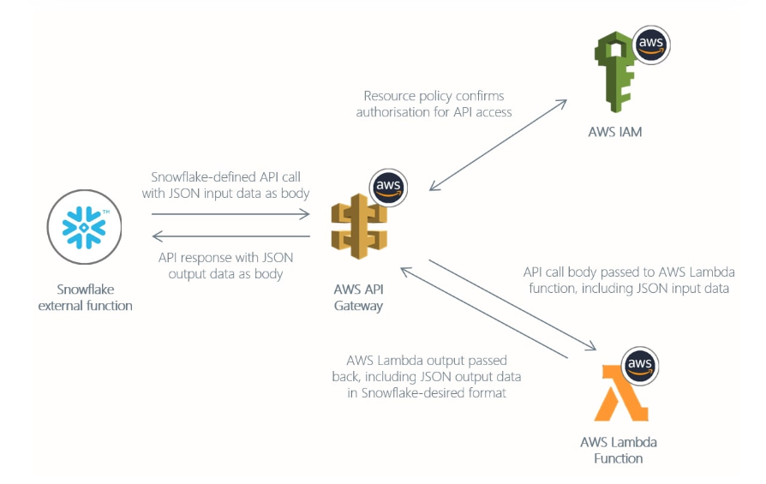

There are 4 components for this integration, namely:
- A snowflake ‘external’ function which will liaise with an AWS application programming interface (an API) proxy gateway, which will receive HTTP messages from snowflake as JSON files and also send HTTP messages back to snowflake in the form of JSON files. Note that the snowflake function cannot talk directly to AWS, it has to talk to AWS via the AWS API Proxy Gateway. The Snowflake external function essentially calls on the external AWS Python Lambda Function and passes that AWS Lambda function variables. It can also receive data from the AWS Lambda function, but it doesn’t do any computation or transformation work itself: the AWS Lambda function does that.
- An AWS API ‘proxy’ Gateway (which we touched upon above), this acts as a ‘go-between’ or ‘gate-keeper’. Snowflake cannot talk to AWS directly using this method, it cannot even ‘see’ AWS or connect directly to the AWS I.P. addresses. It talks to AWS via the AWS API Proxy Gateway and therefore sends and receives messages using HTTP protocol via this Proxy Gateway and (as is evident in the diagram) these messages are in a JSON (JavaScript Object Notation) format, which is an international data interchange standard format.
- We also need to use the AWS IAM (identity access management protocol) to grant specific authorization even to be able to talk to the Proxy gateway. So we set up roles and policies within the AWS IAM service to grant permissions and here we actually need to set up two roles: one ‘account’ role to access the AWS API proxy gateway from snowflake and a second ‘service’ role to execute the Lambda Function within AWS.
- Finally, the fourth component in the integration between snowflake and the AWS Lambda function is the Lambda Function itself which, as being a Python Function is capable of a myriad of possible tasks for example web scraping or complex mathematical functions (such as stochastic integration).

Now, having considered a high level overview of the setup for the integration we can drill down a bit more and look at the setup more specifically:

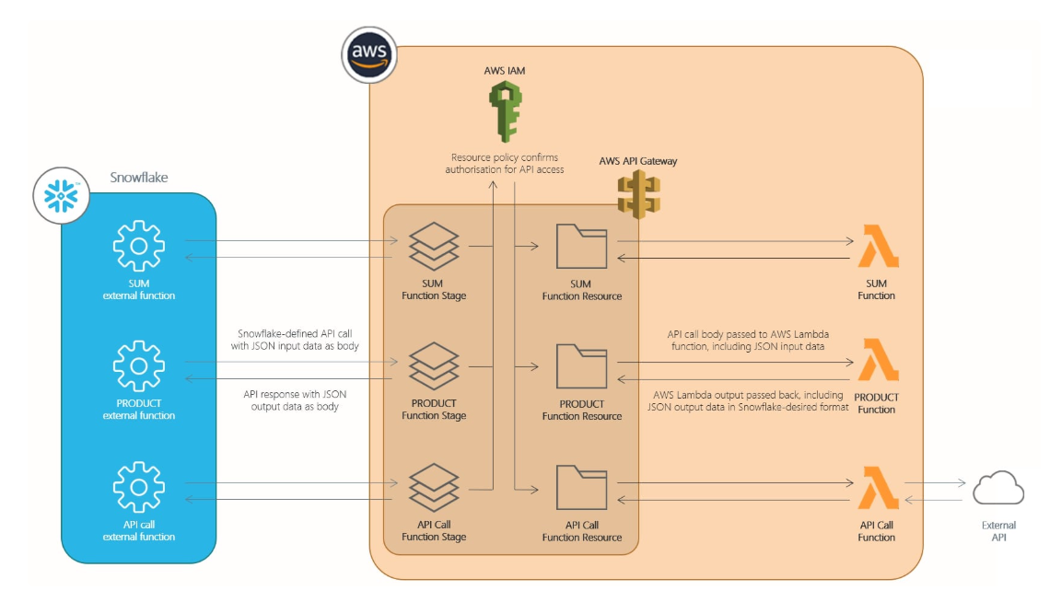

By the direction of the above diagram we need to do the following tasks:

- we need to create an AWS Identity Access Management ‘service’ role which will have the privileges to execute the Lambda Python functions
- We need to create the AWS Lambda python functions
- Off the back of the AWS Lambda Functions which we create, we need to create an AWS API Proxy Gateway via which we can integrate the functions with snowflake
- We then need to create a AWS ‘IAM’ account role which will permit snowflake to access the AWS API Proxy Gateway
- Using the AWS IAM account role (and the account details therein) we need to create a Snowflake API integration Object that can then be used from the snowflake side together with the AWS IAM account role permissions to access the AWS API Proxy Gateway
- We need to create external functions in snowflake that will use the configured Snowflake API integration Object to call on the AWS Lambda function via the AWS API Proxy Gateway.

So much for the initial set up outline, now let us proceed with each step using simple functions initially though ultimately we hope to create a more complex ‘encryption’ Lambda function.

So let’s create some AWS Roles in the AWS Identity Access Management Service.

First we will create what is known as a ‘service’ role and this IAM role will have permissions to execute Lambda Functions.

So in AWS go into the IAM (identity access management) tool and select ‘roles’ – ‘create role’:
